Assignment #1. HTML Basics (Page Structure) Shamshi Abdirash MT2403

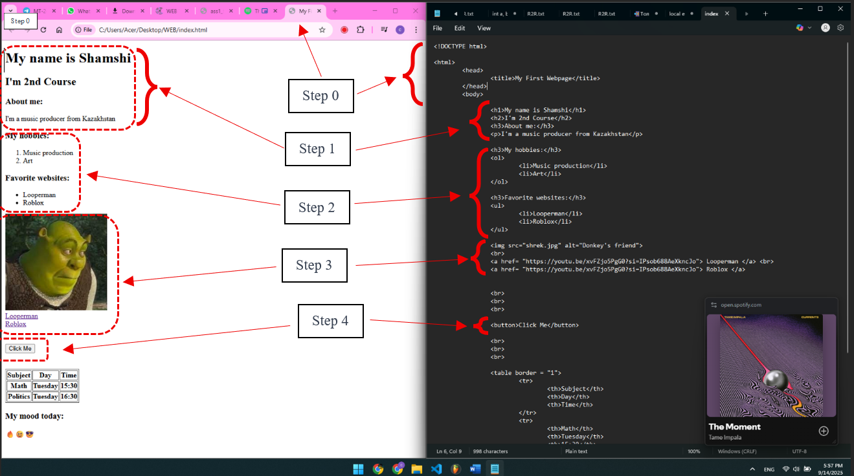

Изображение выглядит как текст, программное обеспечение, снимок экрана, Мультимедийное программное обеспечение

Контент, сгенерированный ИИ, может содержать ошибки.

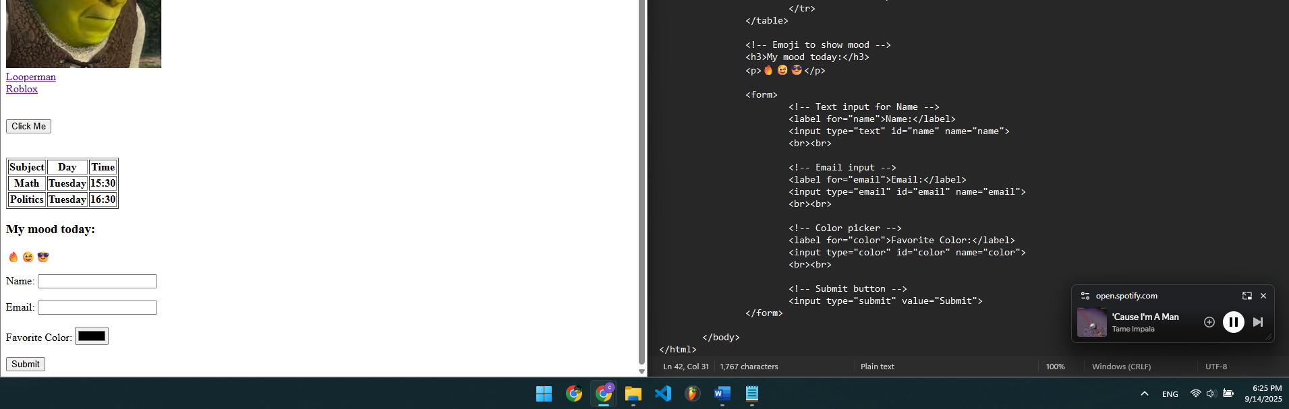

Step 8

In this project, I created a personal webpage using basic HTML elements. The page includes structured text with headings and paragraphs, as well as ordered and unordered lists to present hobbies and favorite websites. I added images, clickable links, and a simple button for interaction.

To extend the functionality, I built a table that shows a small weekly schedule and included emojis to reflect my mood. Finally, I added a contact form with fields for name, email, favorite color, and a submit button.

Overall, the work demonstrates a solid understanding of fundamental HTML tags and structure, covering text formatting, multimedia, navigation, tables, forms, and basic page interactivity.